Question1:

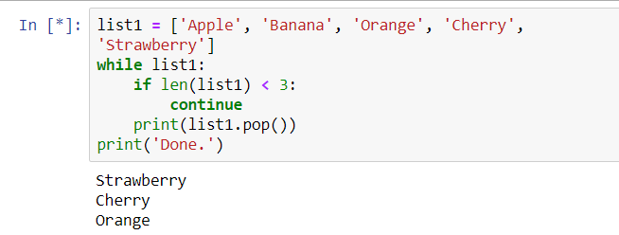

Why done is not printed?

The **continue** statement in **Python** returns the control to the beginning of the **while** loop. The **continue** statement rejects all the remaining statements in the current iteration of the loop and moves the control back to the top of the loop. The **continue** statement can be used in both **while** and for loops.

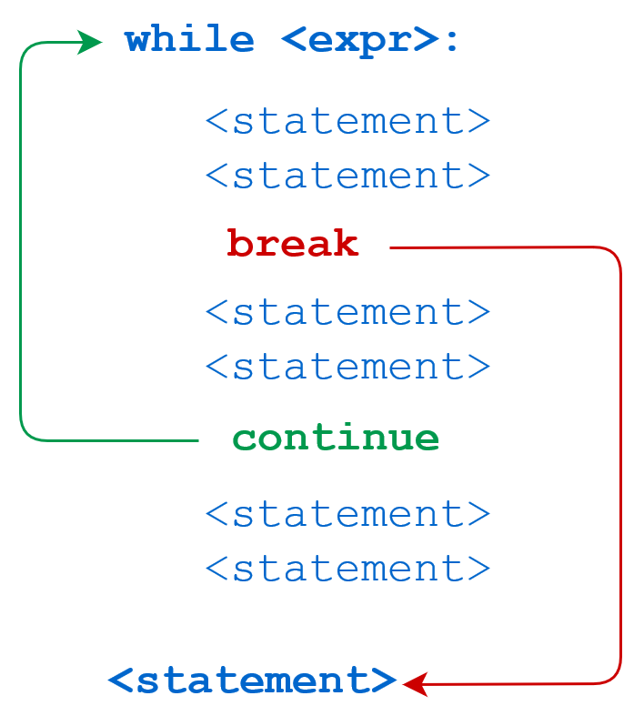

If you tried the following code:

list1=['a','b','c','d','e','f']

while list1:

print(list1.pop())

print ('done')

The output will be

f

e

d

c

b

a

done

If you tried the following code

list1=['a','b','c','d','e','f']

while list1:

if len(list1)<3:

continue

print(list1.pop())

print ('done')

The output will be as follows:

f

e

d

c

Question 2:

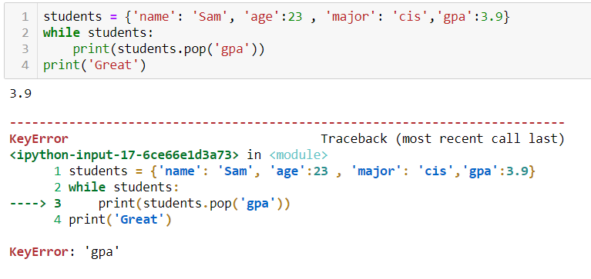

Why I am getting an error?

**Answer:**

**In order to pop a key you do not use while**  
students={'name':'sam',  
'age':23,  
'major':'cis',  
'gpa':3.9}  
print (students.pop('gpa'))

While is used to iterate an operation on a sequence.

**Question 3:**

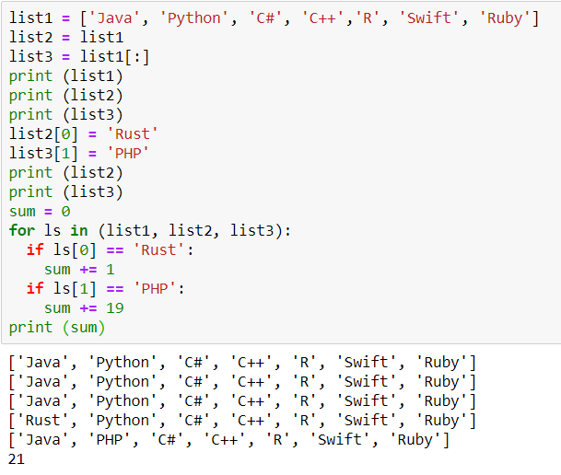

Why I am getting 21 not 20?

